Implementation Notes for the OLE Control and Control Container Guidelines Verification Software

Michael T. McKeown
OLE Technical Evangelist
Microsoft Developer Relations Group

Abstract
This paper discusses development issues and usage information for the verification control and container software, which implement and demonstrate the “OLE Control and Control Container Guidelines, version 1.1”. (These guidelines define a minimum set of expected functionality for OLE controls and control containers in order to promote maximum interoperability). These software modules, the Verification Container (VCONTAIN.EXE or VContainer) and the Verification Control (VCONTROL.OCX or VControl), were developed using MFC 4.0. Particular interest is paid to the VContainer since it make use of the new classes added to this version of that allow an MFC application to host OLE controls.

Verification Container
The Verification Container takes advantage of the new MFC CCmdTarget-based COleControlContainer and COleControlSite classes to verify a control’s compliance with the guidelines. These very powerful classes provide member variables that point to certain key OLE interfaces implemented by the control, as well as type library, registry, and interface information about the control that would normally require a lot of extra code to obtain.

While all interfaces and methods are verified directly through calls on the control using the raw interface pointer returned from QueryInterface, certain members of these two MFC classes are used at various points in the program for the sake of example as well as simplicity. Predominately this occurs in the form of input parameters to these direct method calls or during the process of obtaining pre-verification information.

The Verification Container implements certain additional OLE interfaces (such as IAdviseSink, IDataObject, IErrorLog, IPropertyBag) that are not implemented by the COleControlContainer class yet are necessary as parameters in calls to certain methods. See the MFC Technote #38 for an explanation of how to add these interfaces to your program.

To check an OLE control’s adherence to the guidelines, select the “File/Insert Control…” menu item. A dialog box pops up containing all the registered controls on the system from which you choose the control to be verified; it is then instantiated by its class factory in the Verification Container’s view. A message box signifies either a successful or unsuccessful control creation process. This message is provided primarily for invisible controls (in which the OLEMISC_INVISIBLEATRUNTIME misc. status bit is set) so the user can tell if the control was really created or not.

Since the container has no way of knowing ahead of time which specific control it will be verifying, it must create the control at runtime in a ‘dynamic’ fashion. This is opposed to the ‘static’ pre-determined manner in which the VC++ Component Gallery provides control support for control container applications where the set of controls used is made finite at compile time. When a control is added to the Component Gallery, classes that provide high-level wrapper function access to its a control’s automation interface (properties, methods, and events) are created by reading its type library. These classes can be used within your containing application to easily make use of the functionality of these static controls.

To add this dynamic control creation functionality, we create a ‘new’ object of the CWnd-derived class CVerify, then call the CWnd member function ::CreateControl on this object from within our view’s .CPP file. If we did not use this separate CVerify class and instead called CreateControl against the already existing CWnd-derived view object, the MFC code will not allow the control to create successfully. This is expected since, in general, MFC objects are not reusable - this premise applies to the CVerify object as well.

After instantiation, the user decides whether to verify all of the interfaces and methods in one command, or to verify a subset of the interfaces through a dialog box that allows individual selection of interfaces to verify. After this decision is made, the pre-verification process loads and reads the control’s type library, as well as its registry entries to determine the controls characteristics. The data obtained here assists in determining whether certain interfaces and methods are mandatory or optional for the purposes of categorizing the results and deciding if the control complies with the guidelines during the verification process.

The user is prompted through the pre-verification dialog box (pictured below) for whatever pre-verification information cannot be determined programmatically. Some data, such as whether the control supports mnemonics or accelerators, cannot be resolved through code and will always be obtained through a question of the user. The number of questions displayed varies with the amount of information that can be obtained programmatically.

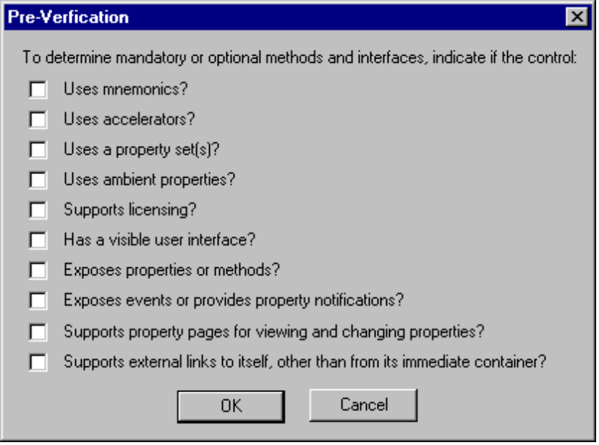

The above dialog shows the worst case scenario where we are unable to load and read the type library and unable to find the proper registry entries. In this case, all the pre-verification information must be obtained manually through asking questions of the user.

PRE-VERIFICATION QUESTION | PROGRAMMATIC DETERMINATION | APPLICABLE INTERFACE/METHOD
Uses mnemonics? | Ask the user; cannot be programmatically determined. | IOleControl::GetControlInfo and ::OnMnemonic
Uses accelerators? | Ask the user; cannot be programmatically determined. | IOleInPlaceActiveObject::  TranslateAccelerator
Uses a property set(s)? | Ask the user; cannot be programmatically determined. | IDataObject
Uses ambient properties? | Ask the user; cannot be programmatically determined. | IOleControl:: OnAmbientPropertyChange
Supports licensing? | Call CoGetClassObject looking for the interface IClassFactory2, which is required for licensing. | IclassFactory2
Has a visible UI? | Read control’s entry in the system registry for the OLEMISC_NOUIACTIVATE flag that says a control does not support UI activation. If this is found, then the control does not support a separate in place active state.  Alternatively, if the control is invisible at runtime, the control does not have a visible UI. | IOleInPlaceActiveObject and  IOleObject::DoVerb for verbs OLEIVERB_UIACTIVATE  and OLEIVERB_INPLACEACTIVATE
Exposes properties or methods? | Read the type library to see if any properties or methods are exposed. | Idispatch
Exposes events or provides property notifications? | Read type library for ‘bindable’ attribute to see if it supports IPropertyNotifySink, or read the CoClass info for an events interface. | IconnectionPointContainer and IconnectionPoint
Supports property pages for viewing and changing properties? | QueryInterface for ISpecifyPropertyPages but do not call any of its methods. | IspecifyPropertyPages and  IOleObject::DoVerb for verbs OLEIVERB_PROPERTIES and OLEIVERB_PRIMARY
Supports external links to itself, other than from its immediate container? | Read the registry for the flag OLEMISC_CANTLINKINSIDE. If present, the control does not support external links. | IExternalConnection

Once all the pre-verification information has been obtained and has been stored in member variables for later use, the code calls CWnd::GetControlUnknown() to obtain a pointer to the control’s main IUnknown. This pointer is not reference-counted by MFC so we do not need to call ::Release at a later point in time

Using this pointer, the Verification Container is then able to call QueryInterface for most of the other interfaces supported by the control. The two exceptions here are IConnectionPoint and IOleInPlaceActiveObject - ::QueryInterface is not the preferred means for obtaining a pointer to these interfaces. Calling IConnectionPointContainer::FindConnectionPoint for the IPropertyNotifySink or the event connection point yields us a pointer to IConnectionPoint. IOleInPlaceActiveObject should be obtained (and saved for later use) as the control becomes in-place active and passes it into the container’s IOleInPlaceUIWindow::SetActiveObject method. (See the KB article Q98678 on the Microsoft Developer Platform CD for more details.).

The cavaet in the latter case is that IOleInPlaceUIWindow is not implemented by this version of MFC, yet it does implement IOleInPlaceFrame which is derived from IOleInPlaceUIWindow. This lead to an override of COleControlContainer’s implementation of IOleInPlaceFrame. For simplicity, the implementations of its methods were copied from OCCCONT.CPP. The SetActiveObject method was then modified to store the IOleInPlaceActiveObject pointer passed into it away for later use.

Using the raw interface pointers from QueryInterface the applicable methods are called. For simplicity’s sake, sometimes dummy parameters are passed (since we are not verifying functionality but only existence).
The result of each call is classified into one of the three categories of “success”, “not verified”, or “failure”. For instance, in any container application it requires additional code to properly call IDispatch::Invoke on a property or method in a control known only at run time. (At design time when we would normally be writing our code to use its specifically named properties and methods using early binding through Invoke). This extra code is really not necessary when simply validating existence. Therefore, the return of any of the DISP_E… automation error codes when calling Invoke verifies implementation. If not implemented, these HRESULT values would not have been returned; they are therefore handled as ‘successful’ error codes.
‘Success’ is obtained when an optional interface or method is called because an optional call cannot cause verification failure. If a mandatory method or interface call returns a positive HRESULT, or a negative HRESULT value besides E_NOINTERFACE or E_NOTIMPL, this is also a success.
Certain pre-verification information may prevent specific methods from being called since it would not make sense some situations. For example, IViewObject2::Draw renders an object’s representation onto a device context. If a control is invisible at runtime (has it OLEMISC_INVISIBLEATRUNTIME misc. status bit set), it does not make sense to expect that control to implement this method and thus we do not call it. Additionally, some methods are dependent upon other methods succeeding before they themselves are invoked and it does not make sense to call them if that earlier method did not execute successfully. For example, the interface IViewObject2::Unfreeze should not be called if IViewObject2::Freeze did not succeed. Interfaces and methods such as these are categorized as ‘not verified’.
A ‘failure’ occurs when a mandatory interface returns E_NOINTERFACE (interface not supported). If a mandatory method returns E_NOTIMPL (not implemented) or is not verified, this is counted as a failure as well.
When all applicable methods on the complete set of interfaces have been called, a message box appears stating whether or not the control complied with the verification process. Note that this will not appear if a subset of the interfaces are chosen in the “Specific Interface Filter” dialog box. Upon dismissal of the message box, the results dialog (pictured below) displays the interfaces and methods in the exact order that they were called. While the interfaces are called and displayed in alphabetical order, their associated methods are usually not. An OLE object’s interfaces can be called in any order, but within an interface, a control is allowed to make certain assumptions about the order in which its methods will be invoked. There exists certain ordered dependencies within the Verification Container code that must not be altered or certain subsequent methods will fail.

Each result line shows the interface or method name, whether it was mandatory or optional, and its HRESULT and accompanying text. If a method was not verified, the reason is shown. If this reason is that a method it was dependent upon did not execute successfully, then that method is listed here as well.

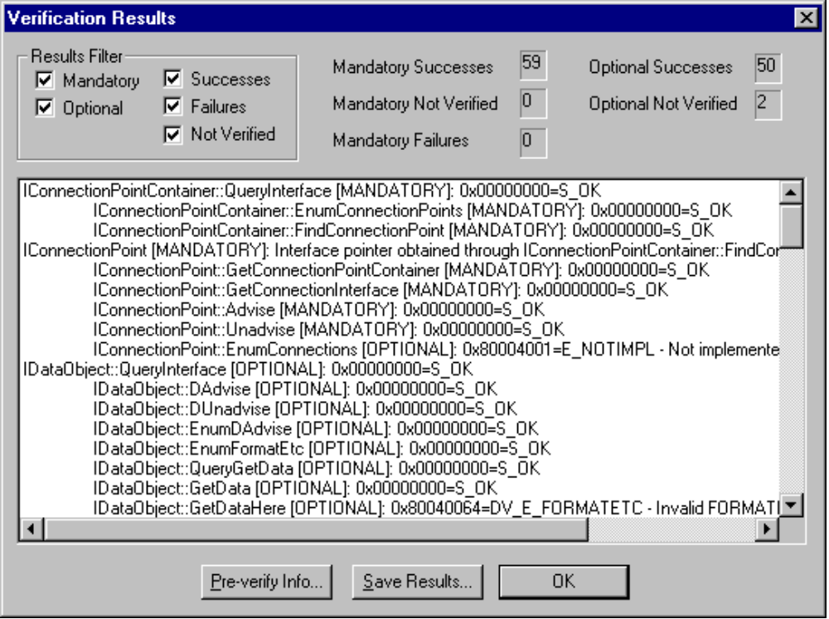

The “Results Filter” allows you to further break down the results into a specific subset. The filter process requires that you select mandatory and/or optional in conjunction with at least one of the possible result categories (successes, failures, and not verified). For example, if you checked just the “Mandatory” and “Successes” check boxes, you would see only those mandatory interfaces and methods that were returned successful results. A tally is displayed for each of the possible combinations (mandatory/optional and success/failure/not verified) for you to view the numerical distribution of the verification process.

The “Pre-verify Info…” button shows the pre-verification information that was obtained both programmatically and via the pre-verification dialog. This is useful in determining why a method or interface was classified as mandatory, optional, or not verified at all. The “Save Results…” button allows you to save the filtered results to a file.

Note that the container only verifies one control at a time; in order to test another control, you must first delete the current control.

No doubt by now you have asked yourself, “Well, what about the old reliable Visual C++ Test Container”? The good news is that the Test Container (TSTCON32.EXE) will still be distributed with Visual C++. The bad news is that it fails when run against the Verification Control because it was written well before the guidelines were established. This is fine, however, since both containers have distinctly different purposes for existence. The Test Container exercises a control’s functionality and provides test capabilities beyond that of the Verification Container. The Verification Container does not test functionality, but rather verifies the existence of interfaces and methods in accordance to the guidelines. Two different programs for two different functions - use both as applicable at various stages in your development process.

Verification Control
Almost identical in structure and functionality to the Verification Container, the Verification Control is used conversely to verify a container’s adherence to the guidelines. Simply drop the Verification Control into your container and click on it to begin the verification process. The container’s interfaces and methods are called, and the results displayed in a similar results dialog box. As you would expect, the two modules verify each other correctly.

The development of this Control-Wizard based control is fairly straightforward. The control itself is a subclassed windows BUTTON control. Like the VContainer, VControl calls OLE interfaces directly on the container. Vcontrol’s base class, COleControl, provides a member variable named m_pClientSite, which is set by the MFC framework when the control is created to point to the container’s IOleClientSite interface. Using this as a arbitrary start (since any other COleControl interface member variable could have been used), the VControl calls QueryInterface on this member variable to obtain an IUnknown pointer. This pointer it subsequently passed to functions that verify the interfaces on the container.

Source Code
The source code files are good samples to use as the basis for your development process. Additionally, they can be an invaluable learning and debugging tool. For tutorial purposes, you may want to step through both the VContain and VControl code modules as they verify each other.

To ensure correct execution, it is recommended that you delete the instance of the control between the two different verification processes. For example, suppose that you instantiate the VControl, then run the VContainer's verification test against it. If you now want to run the VControl's verification test against the VContainer, delete the VControl instance through the VContainer's menu or toolbar, instantiate the VControl again, then click on it to properly verify the VContainer. Remember that these are test modules and they call certain interfaces and methods at times that they would not normally be called, which can lead to unexpected results under certain scenarios.

Summary
By using the “OLE Control and Container Guidelines, version 1.1” and its accompanying verification software, you will be able to maximize your compatibility with other OLE controls and containers worldwide. Please note that as controls evolve to meet the needs of an ever changing industry, the guidelines and the software will be updated accordingly. You can always find the latest versions of the guidelines at the following locations:

FTP Server:
ftp://ftp.microsoft.com/developr/drg/ole-info/olecontrols
CompuServe:
(WinObj forum) GO WINOBJ; library #1 (MS Index/Info)
Internet Web Site:
http://www.microsoft.com/devonly/strategy/ole
MSN:
Get to the MS Internet Web Site via "Categories/The Internet Center/World Wide Web". From there, it is at the same Web site listed above.

